EXERCISE NUMBER: 3

DATE:14/10/2020

AIM:

To write a Python program to remove and print every second number from a list of numbers until the list becomes empty.

PROGRAM:

def remove3number(list):

temp=[]

p=1

s=0

for i in range(0,len(list)):

s=(p+s)%len(list)

el=list.pop(s)

temp.append(el)

return temp

n=int(input())

list=[]

for i in range(0,n):

list.append(int(input()))

p=remove3number(list)

print(p)

LINK:

http://103.53.53.18/mod/vpl/forms/submissionview.php?id=231&userid=1747

OUTPUT:

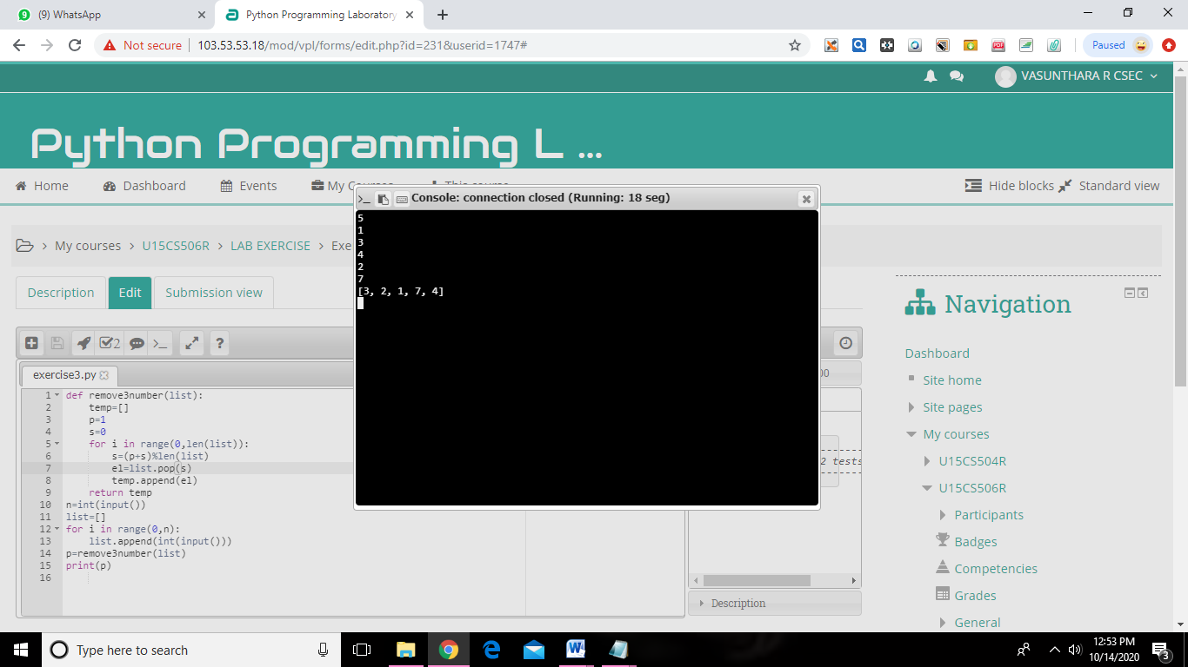

RESULT:

The program is executed and expected output is obtained successfully.